**Lesson 11: Data Representations**

**Do Now:** Answer the questions below as best as you can. Be ready to explain how you used the graph to answer.

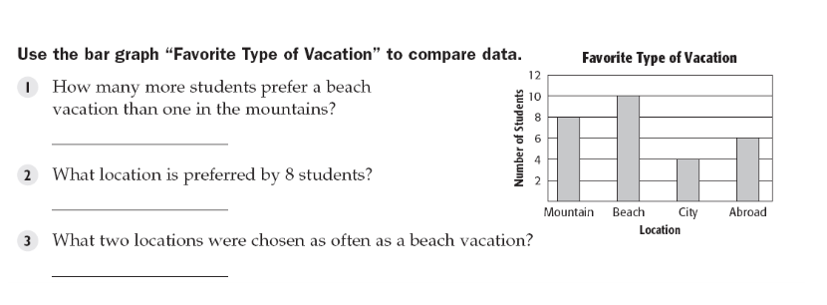

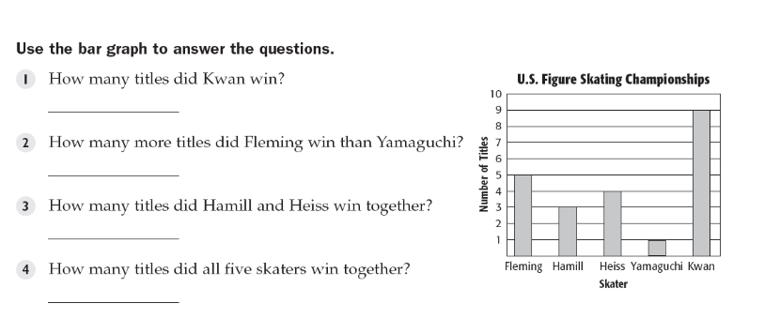

**Key Vocabulary:**

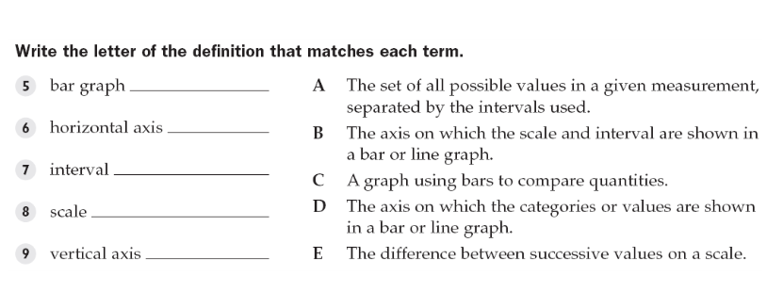

A **scatter plot** is a graph that shows the relationship between two sets of data. In a scatter plot, two

sets of data are graphed as ordered pairs on a coordinate system. A scatter plot may show a pattern

or relationship of the data. The relation may be positive or negative, or there may be no relationship.

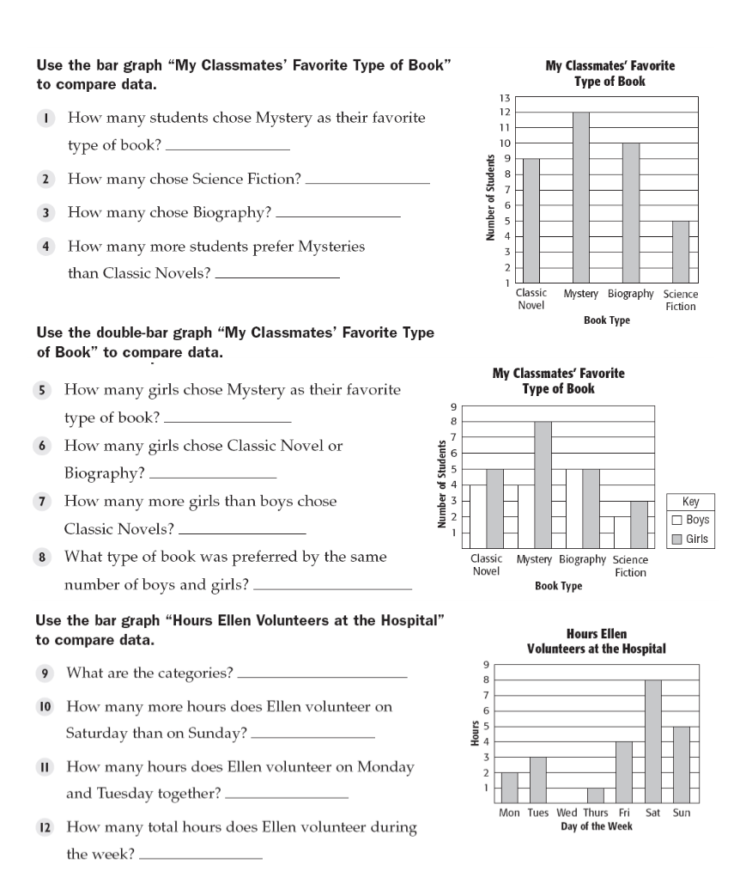

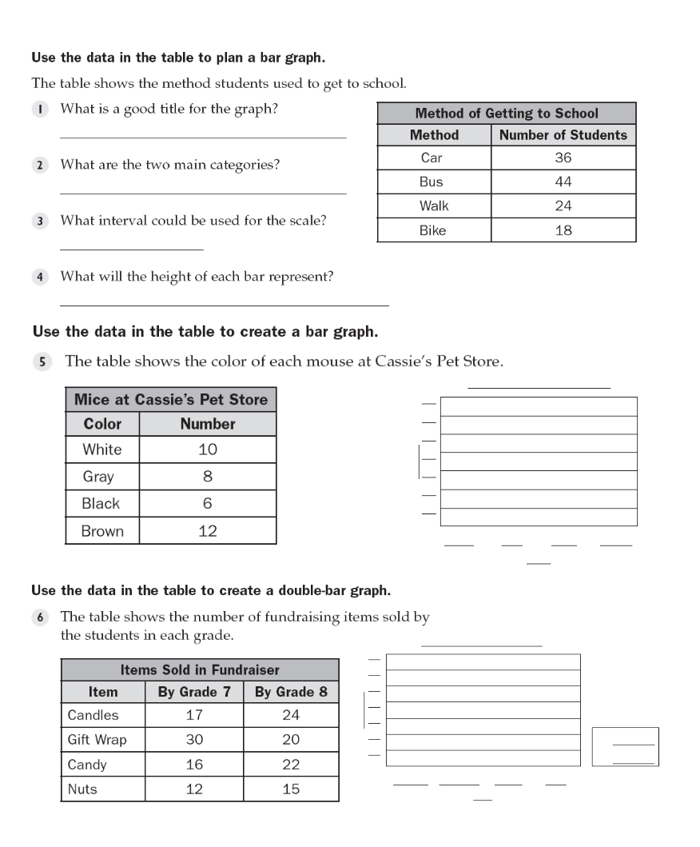

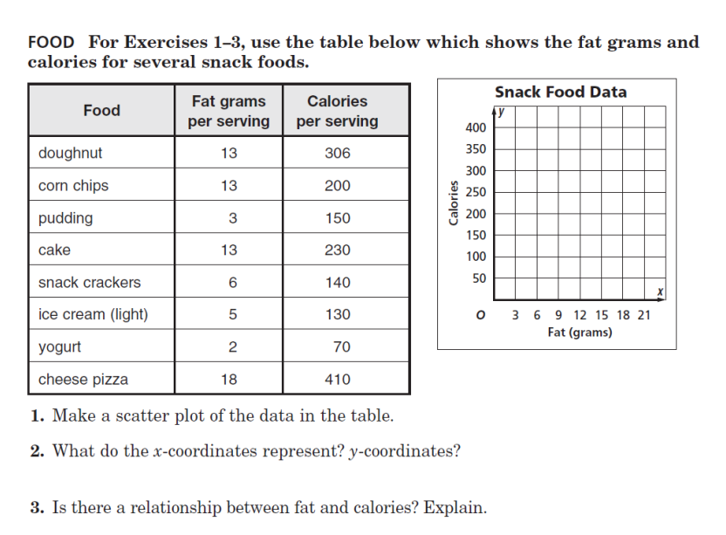

**Structured/Guided Practice:**

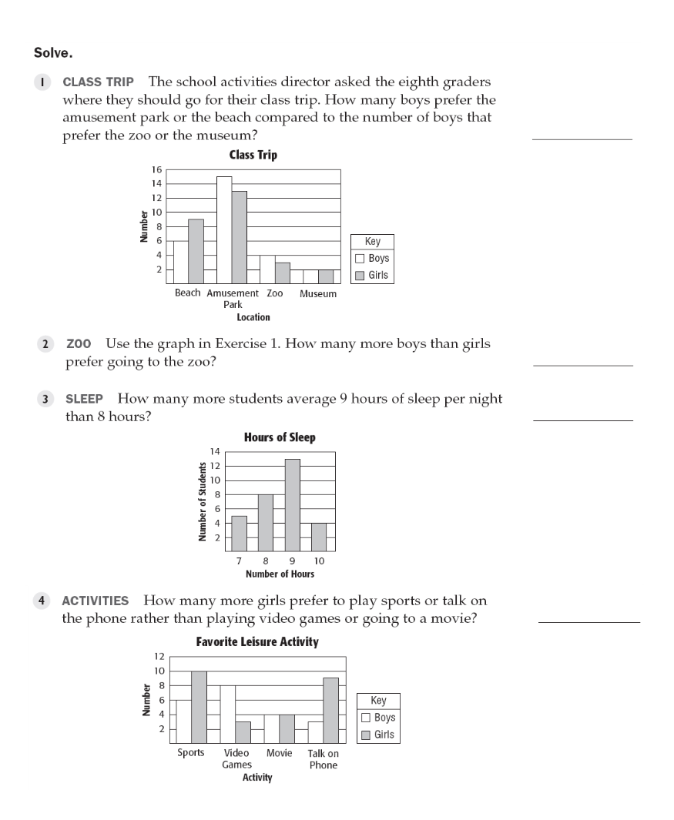

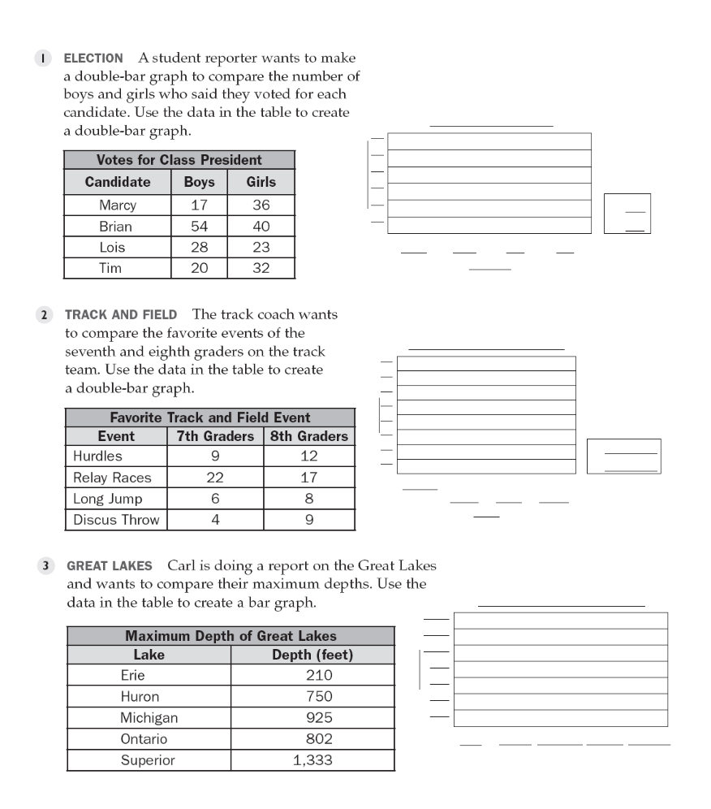

**Independent Practice:**

